- Installing and configuring the Grasshopper Appliance image

This chapter describes how to get started with Grasshopper as an end-user.
Using the Grasshopper appliance will require little configuration work and NO coding work.
To be able to use the Grasshopper appliance image, you are required to have a Raspberry Pi, which is the only cost to get Grasshopper up-and-running.

More info on where to buy: https://www.raspberrypi.org/products/

Choose a Raspberry Pi with an ethernet (network) port:
- Pi1 Model B / B+
- Pi2 Model B

But NOT: Pi1 Model A+

  - Put the image on the SD card

The uncompressed Grasshopper image itself is 1.1GB.
To give enough headroom (for log files etc.) we recommend to use an SD card of at least 4GB. This will give you peace-of-mind after you have deployed it. :-)

    - Extract the Grasshopper .img Zip-file

Use your favourite zip-application to unzip grasshopper_V5.zip on your hard disk.
This will result in a grasshopper_V5.img file.

    - Write the image

- insert an SD Card into a card reader on your PC
- Download http://sourceforge.net/projects/win32diskimager/
- Install and Run win32diskimager
- Click open (blue folder) and select the grasshopper_V5.img file you extracted - Select the Drive Path to your SD card (eg: d:).
- Click Write. Verify this is your SD card, then confirm

  - Grasshopper first boot

Before giving the raspberry pi its final destination (eg. in the basement, connected to the router), you need to

connect it to a screen/tv and attach a keyboard

when you first boot it up.
This is needed because we need to configure the network settings.

- Plug the SD card into your Raspberry Pi and turn it on
- Once started up, the login screen will appear
- Log in with:
dietpi login: root
password: grasshopper

    - Configure the IP settings

- In the terminal, type:

dietpi-config

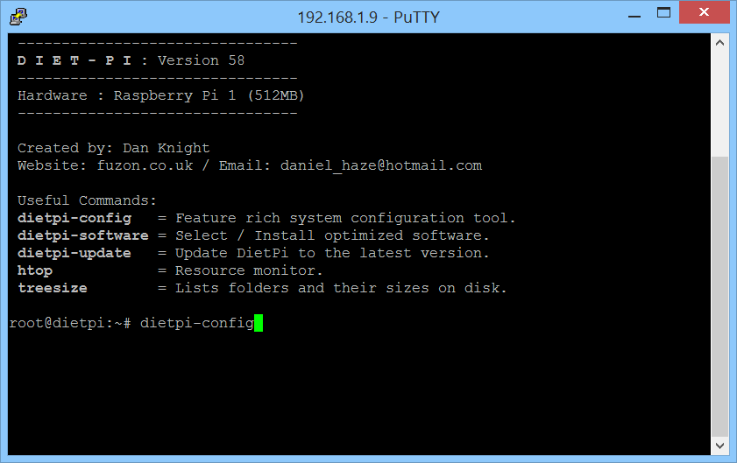

- In the blue screen, choose "7 Networking options" (by using the arrows on your keyboard) and press "ENTER"

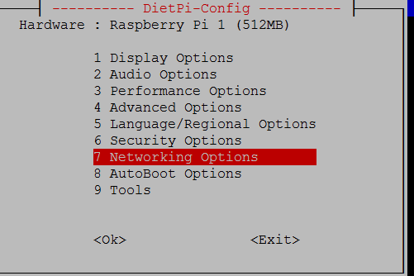

- Choose " Ethernet Change Wired Network Settings" and press "ENTER"

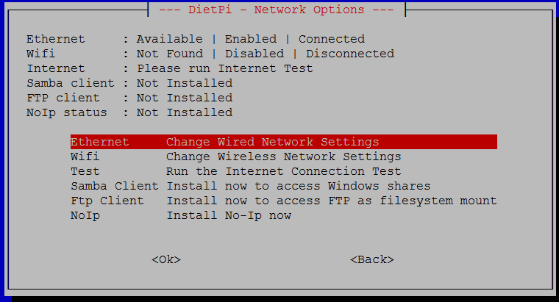

- Choose "Change Mode DHCP" and press "ENTER"

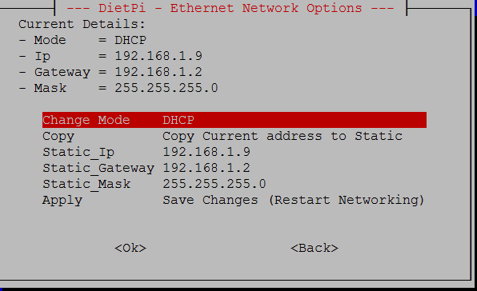

now the value has changed to "Change Mode STATIC"

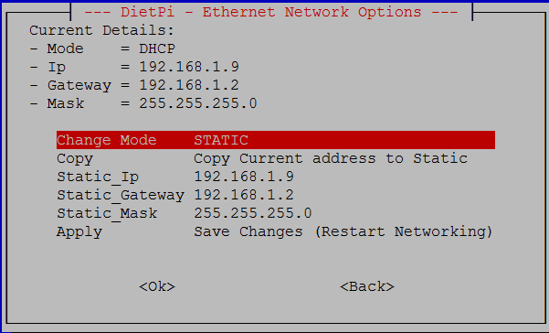

- Arrow down, until "Static_IP ................." lights up and press "ENTER"

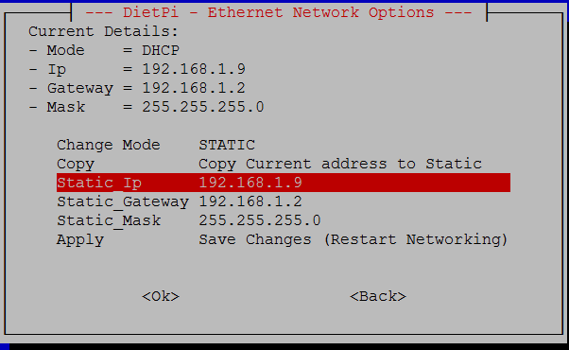

- Enter an IP address in your home-network range which you want to assign as the fixed IP address for Grasshopper and press "ENTER"

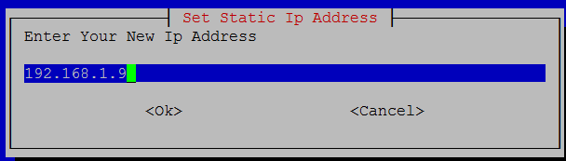

- Now do the same for
- Static_Gateway: enter the Gateway IP address here. This is typically your internet router internal IP address
- Static_Mask: This is your subnet mask. For home networks, this usually is 255.255.255.0

- When finished, select "Apply Save Changes (Restart Networking)"

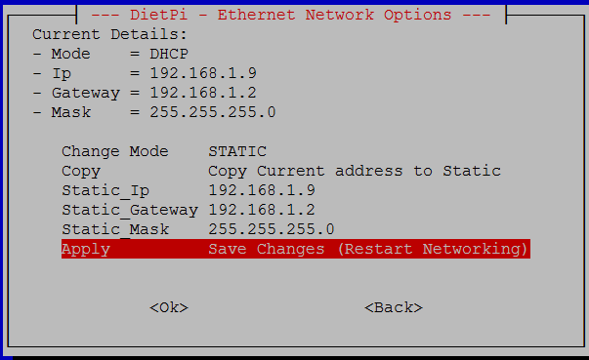

- Select "<Connect>" in the next screen by pressing "ENTER"

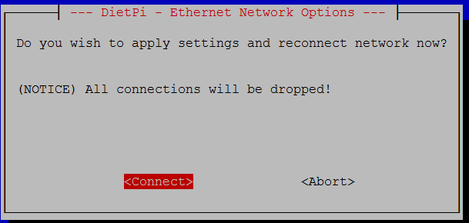

- Press "TAB" key on your keyboard (or alternatively left and right arrows) until "<Back>" lights up and press "ENTER"

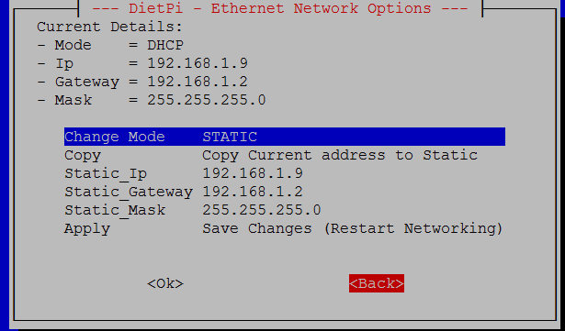

- Press "TAB" key on your keyboard again (or alternatively left and right arrows) until "<Back>" lights up and press "ENTER"

- Press "TAB" key on your keyboard (or alternatively left and right arrows) until "<Exit>" lights up and press "ENTER"

- Press "ENTER" while "<Yes>" is selected to exit dietpi-config

    - Power off the Pi

- In the terminal, type

poweroff

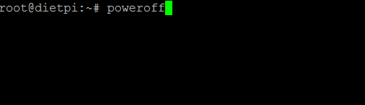

and press "ENTER".

Now you can re-locate the Raspberry Pi to its final destination.
For it to work, it only needs power and wired network connection. So you can put it next to your internet router, wherever it is located.
MIND:
first connect the network cable between Pi and router
then plug in the power
(Otherwise it may not pick up the network)

  - Grasshopper second boot

When the Raspberry Pi is installed at its final location, it is time for the fun stuff.
To get to the fun stuff open a web browser on your PC and go to

http://IPADDRESSOFYOURPI/setup

Remember: IPADDRESSOFYOURPI should be replaced by the IP address we configured during first boot.

    - Expand the filesystem

- Open the tab "System Tools"
- Press the button [Expand Filesystem]

The system will automatically reboot. (This will take 1 minute) After which you can go to http://IPADDRESSOFYOURPI/setup again to continue.

    - Connect Grasshopper to the Bticino Gateway

- Open the tab "Myhome Gateway"

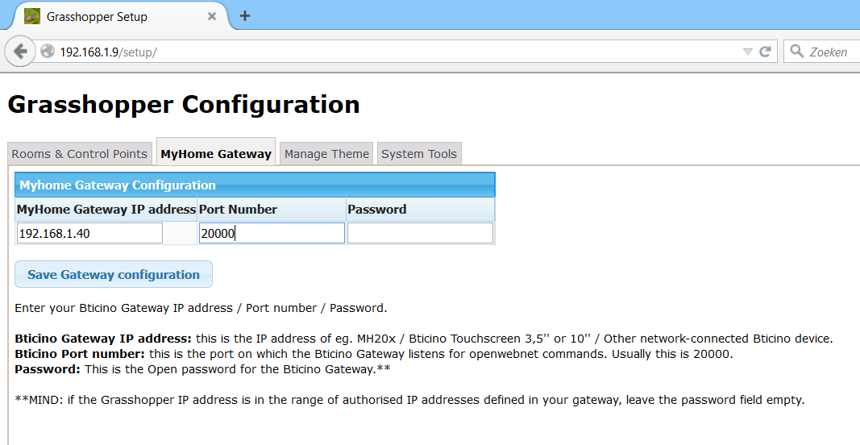

- Enter the Gateway settings as instructed on the web page
- Press "Save Gateway Configuration"

    - Configure Rooms & Control Points

- Open the tab "Rooms & Control Points"

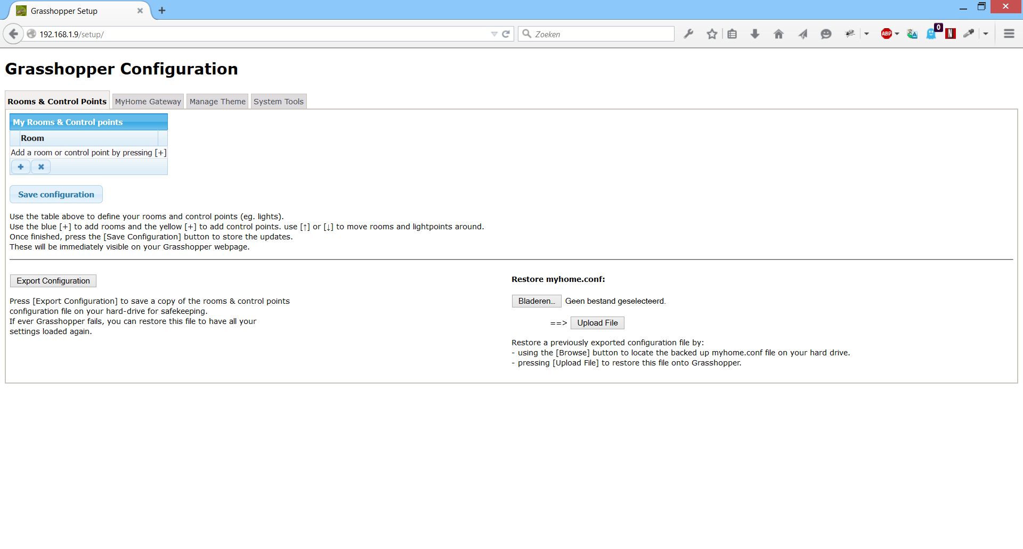

Adding New Rooms:

- Press the button to add a room and a first control point.

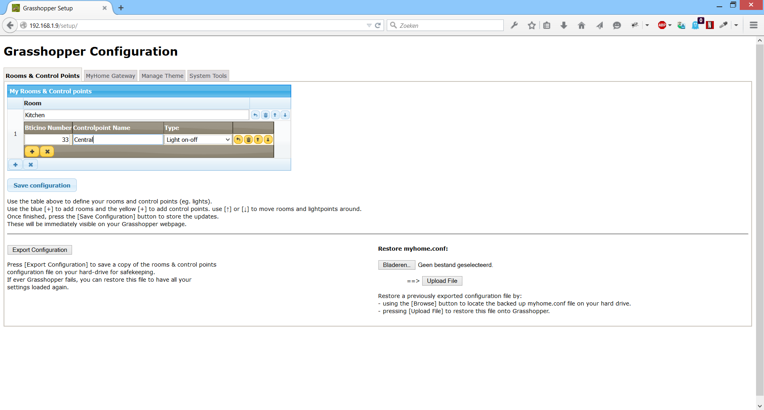

Adding New Control points:
- If you want to define more control points in the room, press

Change the order of rooms and control points on Grasshopper:

- Moving rooms & control points up and down can be done with:
for rooms: 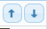
for control Points in a room:

This will result in the rooms and control points being shown in that new order on Grasshopper afterwards.

Controlpoint definition:

A control point is defined by:
- Bticino Number: this is the address the control point has been assigned in the Bticino environment.
- Controlpoint Name: this is the name that defines the control point on the Grasshopper website. You can choose the name freely. It is adviseable to choose a clear descriptive name. (eg. Night light / Sink / Wall / Central / ...)
- Type: in Grasshopper V5, 3 controlpoint types can be defined.
* Light on-off
* Light dimmable
* Motorised screens
This has an impact on how buttons are shown on the Grasshopper site.

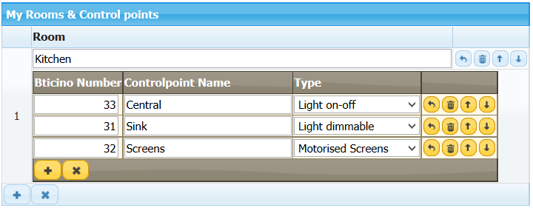➔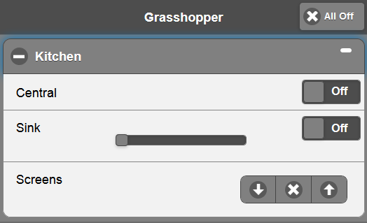

When finished:

- Press the [Save Configuration] button to store your configuration on Grasshopper.
- In your browser, go to http://IPADDRESSOFYOURPI and enjoy the result!

